Chapter 6: Chromosomes and Cell Reproduction

Key Concepts:

1. Chromosomes
- Cell division allows organisms to reproduce asexually, grow, replace worn-out or damaged tissues, and form gametes.
- Bacteria reproduce by binary fission.
- Before cell division, DNA coils around proteins and the chromosomes condense. At cell division, each chromosome consists of two chromatids attached at the centromere.
- Each organism has a characteristic number of chromosomes.
- Human somatic cells are diploid, with 23 pairs of homologous chromosomes. Human gametes are haploid, with 23 chromosomes.
- Sex chromosomes carry information that determines an organism’s sex.
- Changes in chromosome number or structure can cause abnormal development. Karyotypes are uses to examine an individual’s chromosomes.

2. The Cell Cycle
- The life of a eukaryotic cell- the cell cycle- includes interphase, mitosis, and cytokinesis.
- Interphase consists of 3 phases: growth, DNA synthesis (replication), and preparation for cell division. A cell about to divide enters the mitosis and cytokinesis phases of the cell cycle.
- The cell cycle is carefully controlled; failure of cellular control can result in cancer.

3. Mitosis and Cytokinesis
- During mitosis, spindle fibers drag the chromatids to opposite poles of the cell. A nuclear envelope forms. Each resulting nucleus contains a copy of the original cell’s chromosomes.
- Cytokinesis in animal cells occurs when a belt of protein threads pinches the cell membrane in half. Cytokinesis in plant cells occurs when vesicles from the Golgi apparatus fuse to form a cell plate.

Key Terms:

1) Gametes – Are an organism’s reproductive cells, such as sperm and egg cells.
2) Binary Fission – A form of asexual reproduction that produces identical offspring.
3) Gene – A segment of DNA that codes for a protein or RNA molecule.
4) Chromosomes – The DNA and the proteins associated with the DNA.
5) Chromatids – The two exact copies of DNA that make up each chromosome.
6) Centromere – The two chromatids of a chromosome are attached at a point.
7) Homologous Chromosomes – Chromosomes that are similar in size, shape, and genetic content.
8) Diploid – When a cell (somatic), contains two sets of chromosomes.
9) Haploid – When a cell (gamete), contains one set of chromosomes.
10) Zygote – A fertilized egg, the first cell of a new individual.
11) Autosome – Chromosomes that are not directly involved in determining the sex (gender) of an individual.
12) Sex Chromosome – One of the 23 pairs of chromosomes in humans, contains genes that will determine the sex of the individual.
13) Karyotype – An array of the chromosomes found in an individual’s cells at metaphase of mitosis and arranged in homologous pairs in order of diminishing size.
14) Cell Cycle – A repeating sequence of cellular growth and division during the life or an organism.
15) Interphase – A period between two mitotic or meiotic divisions during which the cell grows, copies its DNA, and synthesizes proteins.
16) Mitosis – The process during cell division in which the nucleus of a cell is divided into two nuclei.
17) Cytokinesis – The process during cell division in which the cytoplasm divides.
18) Cancer – The uncontrolled growth of cells; defined by a disorder of cell division.
19) Spindle – Cell structures made up of both centrioles and individual microtubule fibers that are involved in moving chromosomes during cell division.

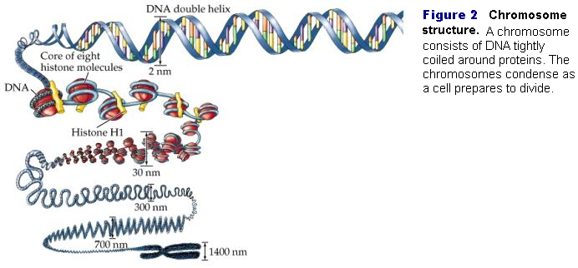
Chromosome Structure

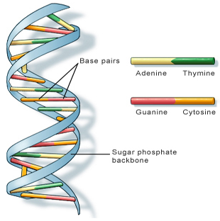
The vast amount of information encoded in DNA is organized into units called genes. A gene is a segment of DNA that codes for a protein or RNA molecule. A single molecule of DNA has thousands of genes lined up like train cars. Genes play an important role in determining how a person’s body develops and functions. When genes are being used, the DNA is stretched out so that the information it contains can be used to direct the synthesis of proteins.

As a eukaryotic cell prepares to divide, the chromosomes – the DNA and the proteins associated with the DNA- become visible, as shown in Figure 2. Before the DNA coils up, however, the DNA is copied. The two exact copies of DNA that make up each chromosome are called chromatids. The two chromatids of a chromosome are attached at a point called a centromere. The chromatids become separated during cell division and placed into each new cell, ensuring that each new cell will have the same genetic information as the original cell.

Fertilization
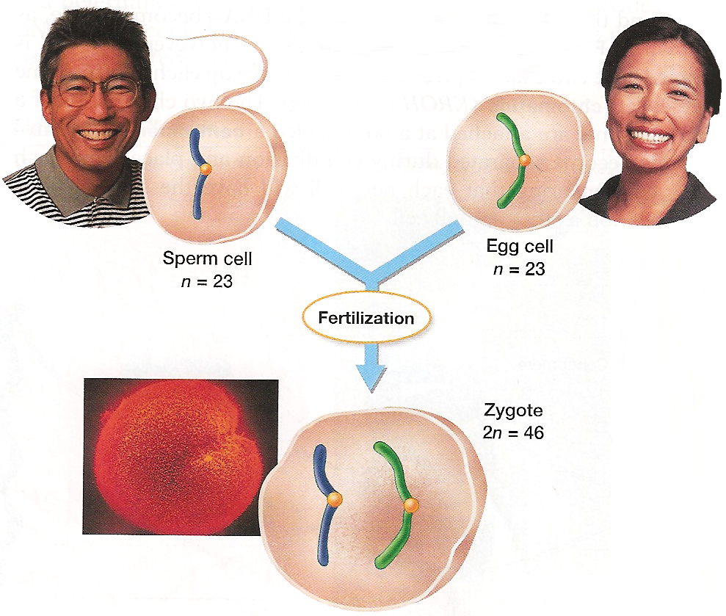
During male and female intervention a sperm is released to fertilize an egg. When one egg and one sperm cell fuse together it is known as, fertilization. Each sperm and egg cell is haploid. They contain half the amount of chromosomes than any diploid cell in the body. These haploid cells have only 23 chromosomes. When they fuse together they create a single celled zygote. This zygote, however, has a chromosome number of 46 and is considered to be a diploid zygote. The sperm and egg cells are the only cells in the body which are haploid; consisting of half the 46 chromosomes in diploid cells.

The Cell Cycle
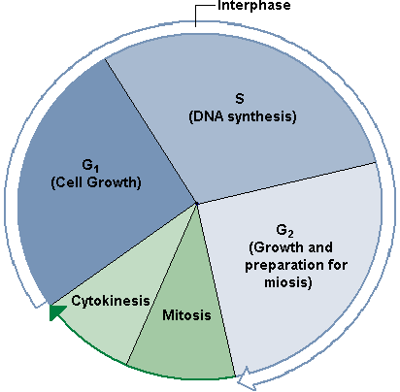
The cell cycle consists of phases of growth, DNA replication, preparation for cell division, and division of the nucleus and cytoplasm. Here are the steps of the cell cycle:
1. First Growth (G1) phase. During the G1 phase, a cell grows rapidly and carries out its routine functions. For most organisms, this phase occupies the major portion of the cell’s life. Cell that are not dividing remain in the G1 phase. Some somatic cells, such as most muscle and nerve cells, never divide. Therefore, if these cells die, the body cannot replace them.
2. Synthesis (S) phase. A cell’s DNA is copied during this phase. At the end of this phase, each chromosome consists of two chromatids attached at the centromere.
3. Second Growth (G2) phase. In the G2 phase, preparations are made for the nucleus to divide. Hollow protein fivers called microtubules are rearranged during G2 in preparation for mitosis.
4. Mitosis. The process during cell division in which the nucleus of a cell is divided into two nuclei is called mitosis. Each nucleus ends up with the same number and kinds of chromosomes as the original cell.
5. Cytokinesis. The process during cell division in which the cytoplasm divides is called cytokenesis.

Control of the Cell Cycle and Cancer

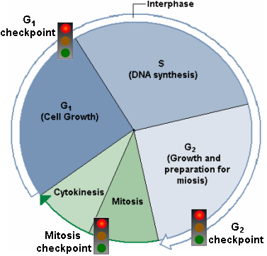
1. Cell Growth (G1) checkpoint. This checkpoint makes the decision of whether the cell will divide. If conditions are favorable for division and the cell is healthy and large enough, certain proteins will stimulate the cell to begin the synthesis (S) phase. During the S phase, the cell will copy its DNA. If conditions are not favorable, cells can typically stop the cell cycle at this checkpoint. The cell cycle will also stop at this checkpoint if the cell needs to pass into a resting period. Certains cells, such as some nerve and muscle cells, remain in this resting period permanetly and never divide.
2. DNA synthesis (G2) checkpoint. DNA replication is checked at this point by DNA repair enzymes. If this checkpoint is passed, proteins help to trigger mitosis. The cell begins the many molecular processes that are needed to proceed into mitosis.
3. Mitosis checkpoint. This checkpoint triggers the exit from mitosis. It signals the beginning of the G1 phase, the major growth period of the cell cycle.
Cancer. Certain genes contain the information necessary to make the proteins that regulate cell growth and division. If one of these genes is mutated, the protein may not function, and regulation of cell growth and division can be disrupted. Cancer, the uncontrolled growth of cells, may result. Cancer is essentially a disorder of cell division. Cancer cells do not respond normally to the body’s control mechanisms. Some mutations cause cancer by overproducing growth-promoting molecules, thus speeding up the cell cycle. Others cause cancer by inactivating the control proteins that normally act to slow or stop the cell cycle.

The Spindle Fibers
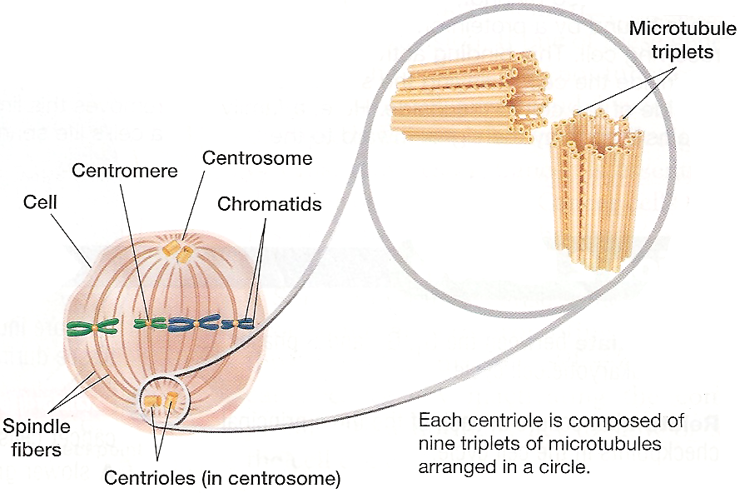
During cell division, the spindle apparatus pulls apart the chromosomes into the two daughter cells.
The spindle apparatus is a structure of the eukaryotic cytoskeleton involved in mitosis and meiosis, often referred to as the mitotic spindle during mitosis and the meiotic spindle during meiosis. Its function is to segregate chromosomes during cell division (either mitosis or meiosis) to the daughter cells. It consists of a bundle of microtubules joined at the ends but spread out in the middle, vaguely ellipsoid in shape. Summarized; these structures are made up of centrioles and spindle fibers, helping to move chromosomes apart during the stages of mitosis or meiosis.
Mitosis and Cytokinesis

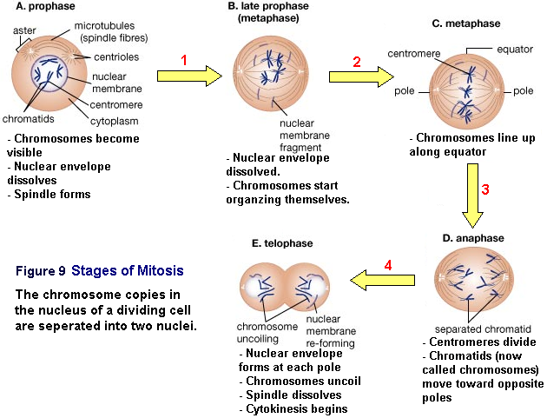

Steps of Mitosis
Step 1: Prophase. Chromosomes coil up and become visible during prophase. The nuclear envelope dissolves and spindle fibers form.
Step 2: Metaphase. During metaphase the chromosomes move to the center of the cell and line up along the equator. Spindle fibers link the chromatids of each chromosome to opposite poles.
Step 3: Anaphase. Centromeres divide during anaphase. The two chromatids (now called chromosomes) move toward opposite poles as the spindle fibers attached to them shorten.
Step 4: Telophase. A nuclear envelope forms around the chromosomes at each pole. Chromosomes, now at opposite poles, uncoil and the spindle dissolves. The spindle fibers break down and disappear. Mitosis is complete.

Cytokinesis
As mitosis ends, cytokinesis begins. During cytokinesis, the cytoplasm of the cell is divided in half, and the cell membrane grows to enclose each cell, forming two separate cells as a result. The end result of mitosis and cytokinesis is two genetically identical cells where only one cell existed before. During cytokinesis in animal cells and other cells that lack cell walls, the cell is pinched in half by a belt of protein threads. However, in plant cells, cytokinesis occurs when vesicles from the Golgi apparatus fuse to form a cell plate, which then separates forming two new plant cells.

